Wildlife Tips and Resources
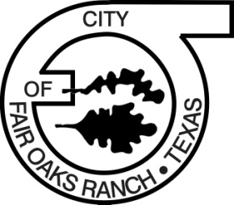

What to Do if You’ve Found an Injured Deer or Abandoned Fawn
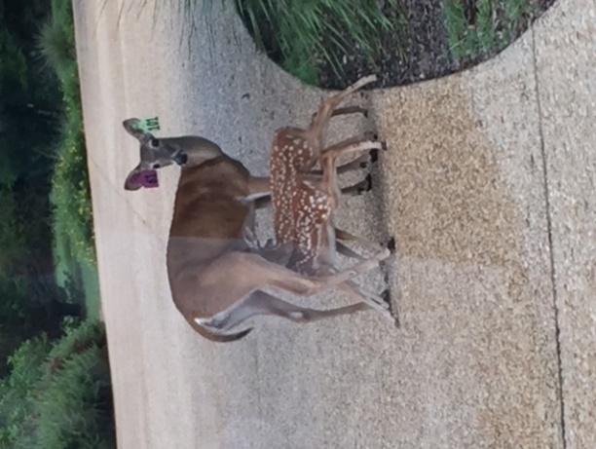
If you find an injured deer that does not appear to be able to ambulate on its own, call the Police Dispatch number at (830) 816-3194 or (830) 249-8645. The Fair Oaks Ranch (FOR) Police department will respond and assess the situation to determine appropriate action to be taken. Normally, deer who can ambulate will not be dispatched. Our officers will attempt to free deer that are entangled in fences if they can safely do so.
Every year, particularly during the spring and summer, hundreds of young wild animals are unnecessarily picked up by the general public and referred to animal officers, game wardens or wildlife rehabilitators for treatment and rearing. The most commonly referred animals are baby birds and deer fawns. While most of these animals are picked up by well-meaning persons, it is important to realize that many such human-animal encounters are unnecessary and can even be detrimental to the wildlife concerned. Below are some tips if you believe a fawn has been abandoned:
1. Whitetail fawns are typically born in early spring through June and are very frail at birth.
2. Axis deer fawns are usually born in early January to mid-April, although fawns may arrive

3. The best action is no action, they are best left to their mothers.

4. A fawn’s white-spots, relative lack of scent and ability to remain perfectly still help it avoid being detected by predators. Even if you cannot see the mother, she is very likely nearby and will return within 12 hours, usually at dawn and dusk. When she comes back, she may or may not move the fawn to a new spot.

5. Do not try to feed the fawn or offer it water as it is totally dependent on its mother’s milk.

A great video on what to do if you find an abandoned fawn – Tips from a Wildlife Biologist You Tube Video is available at: https://www.youtube.com/watch?v=iUZmdWngGw4.

Abundant Varieties of Wildlife Live in FOR
For those who are new to Texas or to the Hill Country, we live in an environment surrounded by wildlife of all varieties to include large and small mammals, birds, reptiles, insects and amphibians.
The City enacted a no feeding ordinance in October of 2016 to prevent clustering of wildlife and to encourage normal wildlife distribution. This has improved the safety of residents as well because we are seeing a marked difference in the number of deer in subdivisions and on roadways all hours of the day and night.
An excellent way to experience wildlife here in the City is to experience the Fair Oaks Ranch Homeowner’s Association (FORHA) members only Parks and Trails system. To learn more, if not already a member, join FORHA and access their website at http://www.forha.org/main.asp. On the FORHA home page click on parks and trails to find a map with locations of all the parks and trails.
Your Pets and Wildlife

Wildlife and pet interaction is discouraged to prevent health and safety concerns. State laws and City ordinances in place to ensure the safety of your pets include:

- NOT let pets roam unrestrained. Small pets can easily become prey to larger wild mammals and all pets may become injured by wildlife during interactions such as when animals are startled and react defensively.
- Tagging and micro-chipping pets. Lost animals found without collars but micro-chipped can more easily be returned to owners.
- Registering your pet with the City for a nominal fee ($5 neutered and $10 unneutered). This added layer of security enables the safe return of your pet to their loving home. For more information on how to register your pet, call the Fair Oaks Ranch Police Department Monday through Friday at (210) 698-0990.
- Do vaccinate. Vaccinations are critical in avoiding unnecessary and expensive medical care for your pet and their early demise. For more specific information on required and optional vaccinations to protect your pet, contact your veterinarian.
Hidden Wildlife Dangers – Venomous/Non-venomous Snakes and Insects

The City is home to any number of venomous and non-venomous snakes and insects native to Texas. Since education is key to injury prevention, please make yourself familiar with these forms of wildlife and avoid direct contact/interaction. Even non-venomous bites or stings may be painful and can cause infections or other health issues.
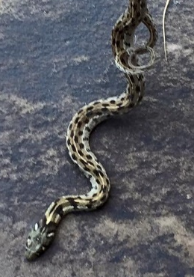
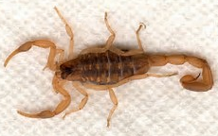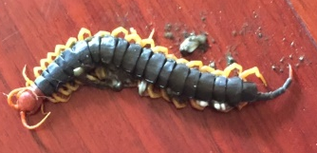
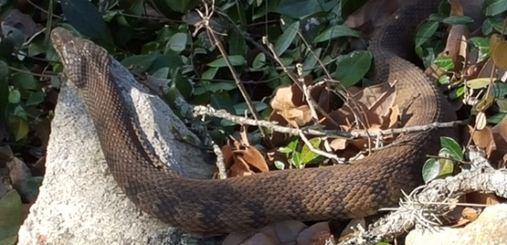
Monarch Butterflies and Native Pollinators

Monarch butterflies and other pollinators such as bees, moths and other insects are a critical part of our environment and human food production. According to the U.S. Fish and Wildlife Service up to 80% of all plant species are pollinated, mostly by insects. Three quarters of all the world’s common food crops require insect pollination, to include coffee, tea, chili, berries, tomatoes, fruit and nut trees, spices and vegetables. In addition, fields of livestock crops such as alfalfa and clover are pollinated by insects.
The Monarchs of Texas need our help. It is losing is habitat and the milkweed plants that used to grow in that habitat, which Monarchs depend on for laying eggs and caterpillar food. As a result, , its population across the United States and into Canada and Mexico have been dropping by about 90 percent over the past 20 years, reflecting a drop of about 970 million butterflies by 2015!

Ten Things You Can Do in Your Yard to Encourage Pollinators:
- Plant a pollinator garden
- Provide a water source
- Provide shelter and overwintering habitat
- Stop using insecticides and reduce pesticides
- Provide sunny areas out of the wind.
- Use native plant species whenever possible.
- Grow flowers throughout the season.
- Plant in clumps and layers.
- Use compost instead of commercial fertilizer.
- Look, but do not touch.

For more information on the Texas Monarch and Native Pollinator Conservation Plan and Management Recommendations for Native Insect Pollinators in Texas, visit the following two websites:

http://tpwd.texas.gov/publications/pwdpubs/media/pwd_rp_w7000_2070.pdf
or
Http://tpwd.texas.gove/publications/media/pwd_bk_w7000_1813/pdf.

To increase citizen awareness, the City has funded a Monarch garden on City property. Volunteer city staff built it and are working to maintain the garden as a citizen education venue.

There are many available resources to become better informed on these and other forms of wildlife. One such site is the Texas Parks and Wildlife Department Wildlife Diversity YouTube Channel at:
https://www.youtube.com/playlist?list=PL47868EA6F87650FA.

Additional information is available on the City’s website: Go to http://www.fairoaksranchtx.org/ and click on the link shown below on the Home Page to find wildlife articles, dates of upcoming events, and other sources for wildlife information.



Wildlife Education Committee (WEC) Members, Consultants and Liaisons


From left to right: Chris Cook, MaryAnne Havard (City Council Liaison), Teal Manley-Harris, Dr. Bruce Nicholson, Dee Anna Manitzas (Educational Consultant). Jessica Alderson, (Texas Parks and Wildlife Consultant) is not pictured.

You may contact WEC members by calling the City of Fair Oaks Ranch at (210) 698-0900 to leave a message.

